Winter Garlands
In the winter, when it gets freezing cold,
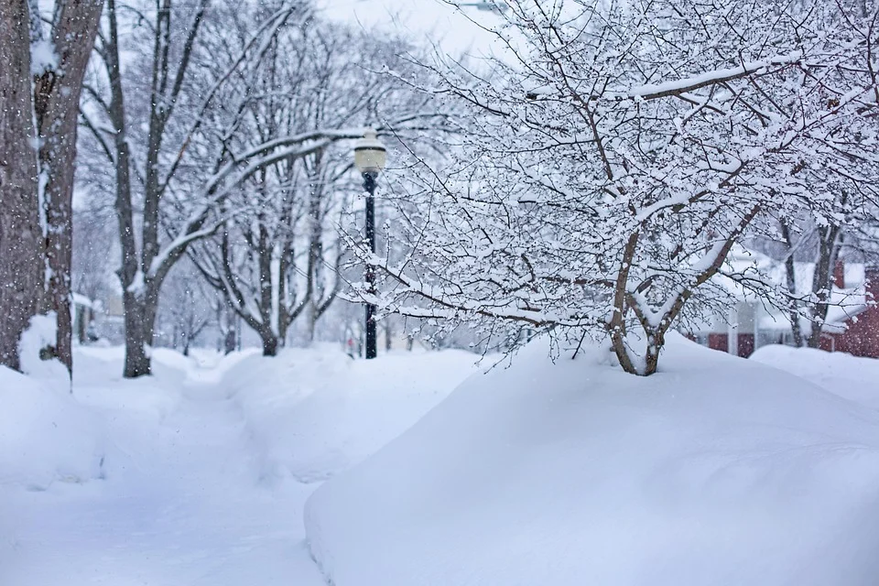
the birds find it difficult to find food.
There is a popular holiday decoration that also feeds the birds.

All you need is some unsalted popcorn.
And some cranberries.
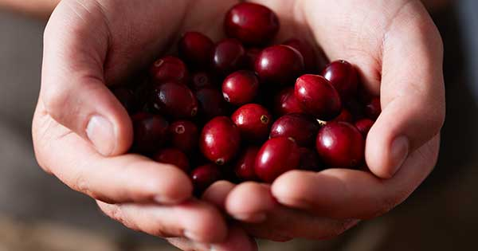
String them together with a thread and needle.
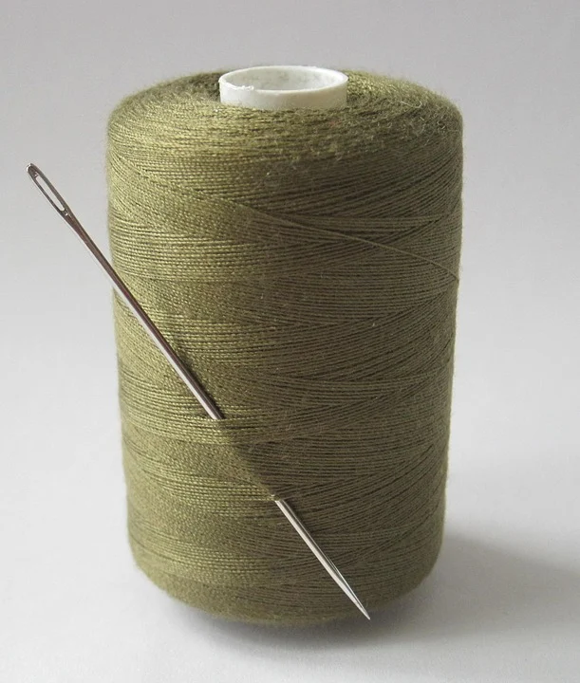
Decorate the outside of your home with your winter garland.
We hope you have many visits from your neighborhood birds!

